**08/12/2022**  
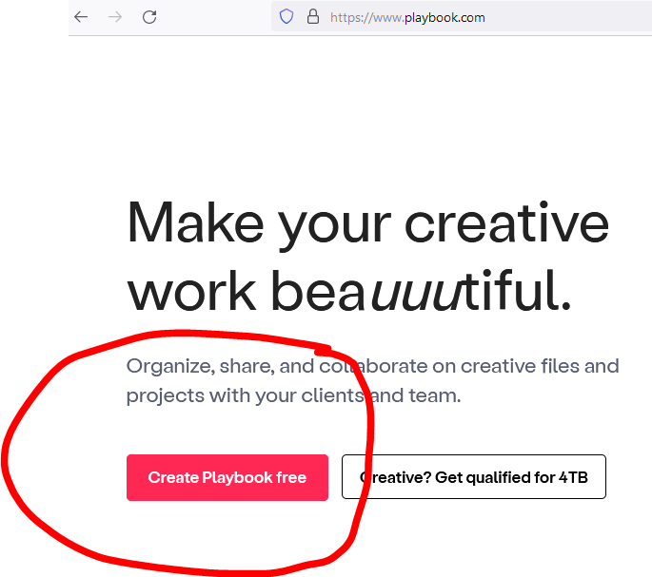

Please choose a color like this as I mentioned on hussle which was like this.

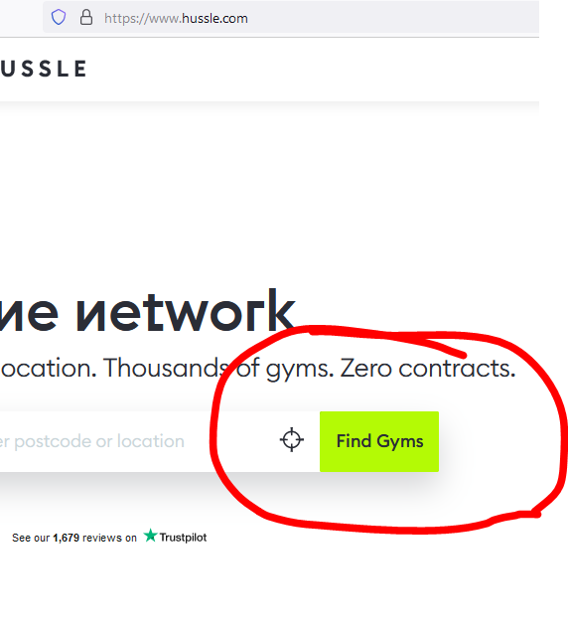

**You can chose Cobalt color or Pink color, not sure, Something chatkila and stand out. Front end designer might suggest something.**

**Fonts are very basic, I gave hussle and few other website as reference. Please use soft and sharp bold font.   
Please look at the design hussle used, please keep backround white and grey with dark grey fonts plus some color here and there to keep website stand out, AS THE HUSSLE WEBSITE.**

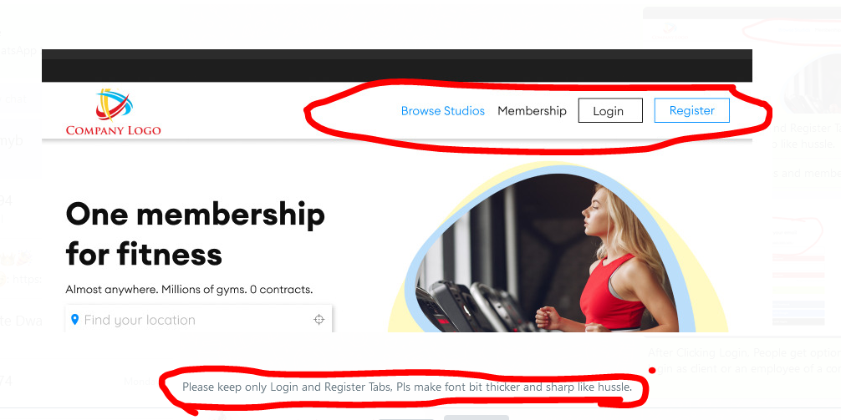

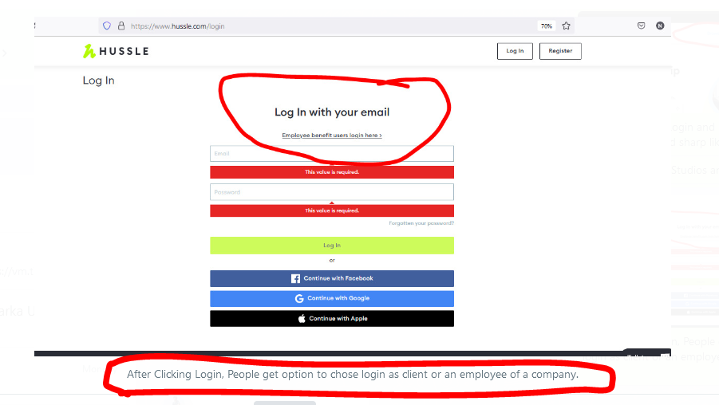

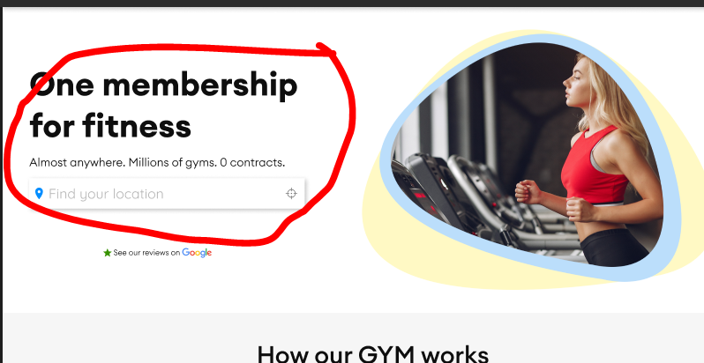

**Thousands of Sports, Fitness, Gym Session or Adventure.  
Zero Contract. Unlimited Activites.**

Instead the photo of a girl on right please put few photos of kids football session, Gym Kickboxing session, Crossfit and Paintball Adventure. Please see the referenced websites.  
  
hussle.com, https://www.getfitso.com/, https://classpass.com/, https://geronigo.com/, https://gympass.com/, https://www.fitternity.com/, https://fitpass.co.in/,

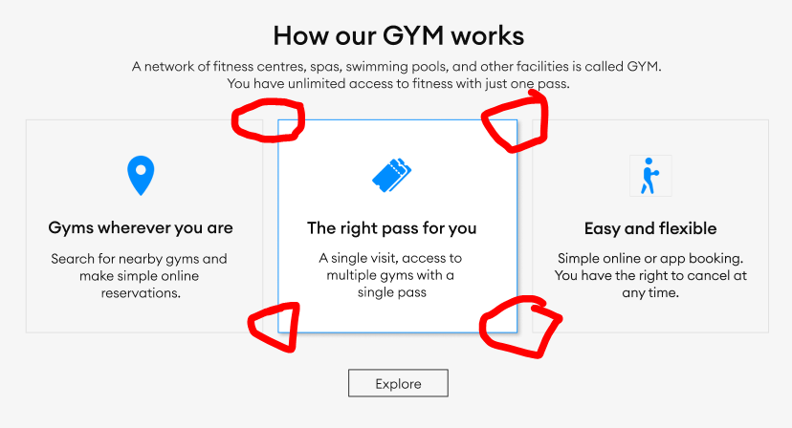

All boxes edges should be curved.  
Background little darker like Hussle.

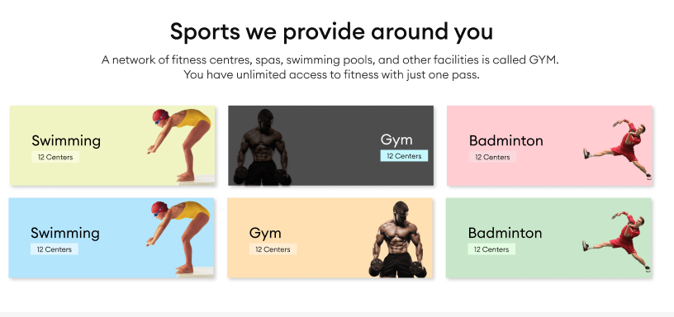

First Kid playing football, Second Gym Boxing Session, Third women cycle session in gym,  
Fourth Adventure session like Painball from geronigo.com website, Fifth Crossfit pic fitpass.co.in, Sixth, Swimming session.